F.I.S.A.C
Italian Federation of Acrobatic and Choreographic Sports

Viale C.Colombo, 35 – Cesenatico (FC) Italia
tel./fax: +39 0547 84935, e-mail: segreteria@fisacgym.it

___________________________________________________________________
General Secretary: Franca Casadei

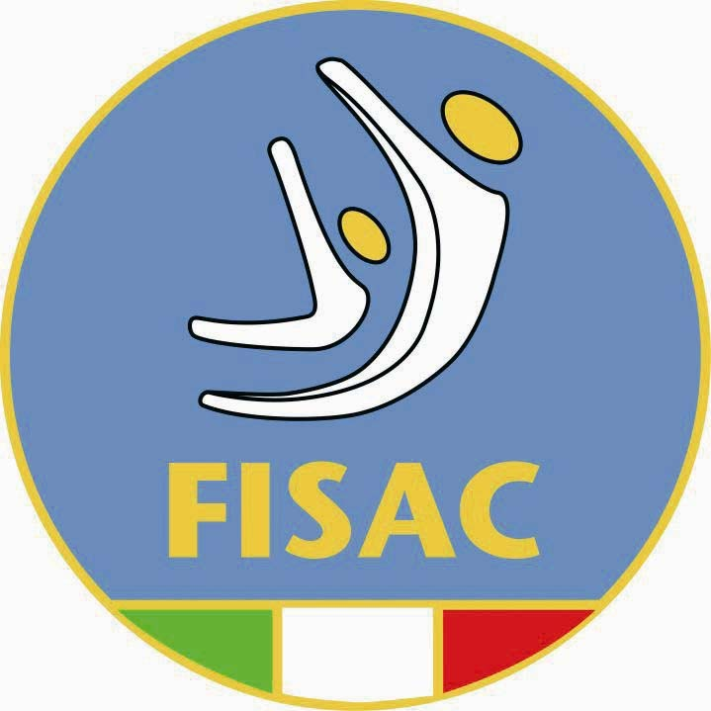

INTERNATIONAL TEAMGYM CUP 2025
Youth, Junior and Senior

Cesenatico 06 - 07 – 08 June 2025
Final Step

A/ General info

- Organizer: FISAC – Italian Federation of Acrobatic and Choreographic Sports

- Date: 06 – 07 – 08 June 2025

- Place: Pala Oasi 2 – Via Cristoforo Colombo 18 – Cesenatico (FC)
- Org. committee: FISAC President Bianchi Cesare
Secretary and Finance Casadei Franca
Competition equipments director Maestri Massimiliano

- Registration: Nominative entry within 10th May 2025

- Address to send Nominative entry forms and the music for the exercises : segreteria@fisacgym.it

Address to send accomodation requests: direzione@villaggioaccademia.it

- Accomodation : Booked and covered by teams (www.villaggio accademia.it)

- Please send your requests ASAP.

Accademia Village offer you a special formula all including!
Full board accommodation (breakfast, lunch and dinner from the Friday dinner to the Sunday lunch included) in 2/6 beds room with bathroom.

€. 80 (standard rooms)
€ 94 (superior rooms)

SPECIAL OFFER FOR ALL THE PARTICIPANTS :
Six nights chosen in the period between June 3 to June 15
€ 220 full board accommodation, gym halls, swimming pools and beach. Service card for free!!!!!

- Travel costs: Covered by teams. Free transfer from and to Cesenatico station (from 8 to 18)

B/ Technical statements

10. Regulations: According to :
- International Cup of Clubs TeamGym Technical Regulations 2025
- Statements in this invitation and Work Plan

11. Apparatus : Team : Floor – Tumble - Trampet
Micro team : Tumble - Trampet

12. Equipment : Following equipment to be available at competition hall
Carpet for Floor 16 X 14 (14 X 14)
Tumble Track 15 m, run up 16 m, landing area, additional landing matt
Trampets 40 springs, 36 springs run-up 25 m, landing area, additional matt.
Vaulting table 130 – 165 cm

13. Warm up : Possible at dedicated separated place at the competition hall, prior organized trainings.

14. Participants: Gymnasts that have been selected for National Team to participate at the last two (2) Teamgym European or Continental Championships are not allowed to compete in respective ICC cycle

15. Teams : Each gymnast can compete only in one team and one category and section.

Age categories :

YOUTH II: from 8 to 10 years (born 2014 – 2017*)
YOUTH I: from 11 to 13 years (born 2011 - 2013)
JUNIOR: from 14 to 16 years (born 2010 - 2008)
SENIOR: 17 years and older (born 2007 and older)
OPEN: 8 years and older (born 2016 and older)
The gymnasts have the right to participate if they reach the determined min/max age during the year of the competition.

Size of the teams:

TEAM: 6-10 gymnasts, gymnasts may represent maximum three clubs and be part of one team and competition (the same gymnast cannot participate in TEAM and MICROTEAM competition).

MICROTEAM: 3-5 gymnasts may represent maximum three clubs and

16. Entry fee: Team competition – 200 eur per each team
Micro Team – 100 eur per each team
Payment of the competition by banking transfer or directly at the registration
17. Protests: According International Cup of clubs Teamgym Technical Regulations 2023

18. Anthems and Flags Please remember to carry with you one copy of your national Anthem and Flag.

Prizes presented by the Academy Village

For placed participating teams (Max 10 gymnasts and 2 coaches)
TeamGym - Youth (Combined), Junior (M, W and Mix), Senior (M, W and Mix) Open
- 1st place: 6 persons completely free, the remaining of the team 50% discount for one week stay at the A.V. (Academy Village- Cesenatico- Italy)

For placed participating micro teams (Max 5 gymnasts and 1 coach)
Micro Teams Youth (Combined), Junior (M, W and Mix) ,Senior (M, W and Mix) Open
- 1st place: 3 persons completely free, the remaining of the team 50% discount for one week stay at the A.V.

For all TeamGym, and Micro Team disciplines, the above conditions will be valid only if in the final ranking of each age category and gender of Cesenatico step there are 3 or more teams or micro teams and if the teams or micro teams have participated to another step of the Cup!!!


Sponsored by:

Cesenatico, 6 December 2025
Mr. Bianchi Cesare
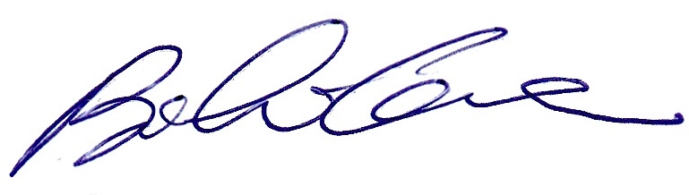
FISAC President

